Guide: How to use the company portal

On the company portal, you can enrol employees in or withdraw them from your pension scheme and AP Health Insurance, update salary information, change employee information and much more.

1. Log on to the company portal
Go to the company portal
You can also access the portal from appension.dk by clicking Erhverv (Business), Virksomhed (Company) and Til administratoren (For the administrator). Log on using MitID.
If you do not have a MitID employee signature, you can typically contact your company’s IT department to get one.
2. Select the relevant page
You are then directed to the below page, where you select the action you want to perform. It is also on this page you can change to the English language page.
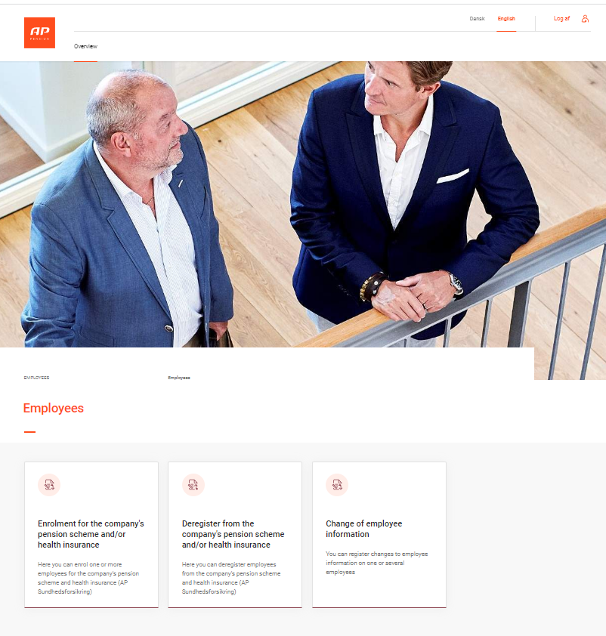

2.A Enrolment
Here you can enrol one or more employees in your pension scheme by completing a form or uploading a file. If your company has chosen AP Health Insurance, the employees are automatically enrolled in the insurance if you use the first or the second box below to enrol them in the pension scheme.
If you want to enrol one or more employees in the AP Health Insurance only, you need to use the third or the fourth box.
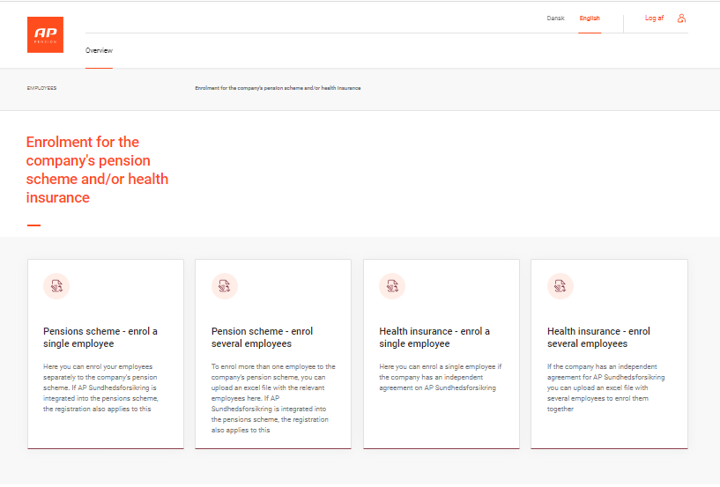

2.B Withdrawal
Here you can withdraw one or more employees from your pension scheme by completing a form or uploading a file. If your company has chosen AP Health Insurance, the employees are also automatically withdrawn from the insurance if you withdraw them from the pension scheme using the first box.
If you only want to withdraw one or more employees from the AP Health Insurance only, you need to use the second or the third box.
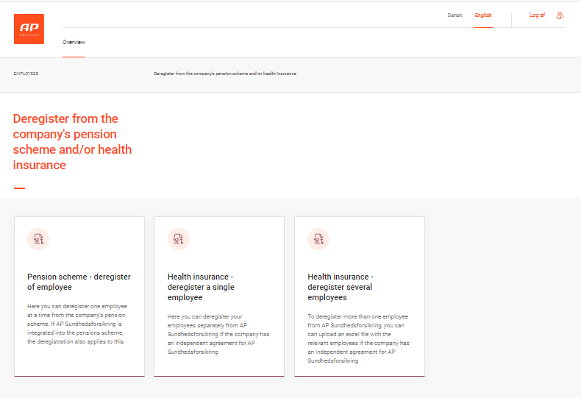

2.c Changes
Here you have several options to register changes to employee information, for example salary changes.
If you click Change in salary and occupation for several employees, you get a template you can use to register information on more than one employee.
It is important that you use the template and only fill in the listed fields. No extra columns/rows may be added to the sheet.
